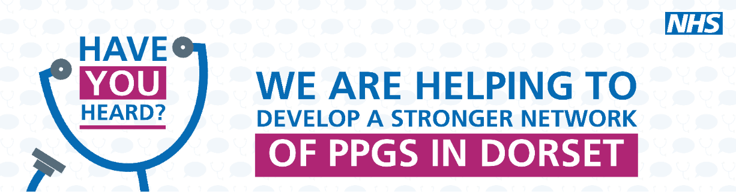
Bridges Patient Participation Group (PPG)
8th March 2022
Bridges Medical Centre/Zoom

Notes of Meeting
 |  | Action
1 | Welcome and apologies  Present: Sue Brunt (Chair), Dr Karen Kirkham, Lennie Edwards, JW, AR, MB, PF,  FK, GC, LO, SE, PM, JW  Apologies: Jim Gammans (CCG), AL, GC, BS  Sue started the meeting by thanking Katharine for all her hard work in supporting the PPG. Katharine is now busy doing training as part of her nursing. Lennie will take over the admin until someone else is appointed.
2 | Surgery update  Staff Changes –  Sue Lewis and Sue Starbrook (Nurses) have retired and Gail Cane (Health Care Assistant) is retiring at the end of the month. 2 new Nurses have started (Victoria Schooling and Susanna Bell) and a Health Care Assistant (Jenny Wood) is due to start soon.  Dr Becca Trickey left in February to work closer to home and Dr Ivan Hall is retiring at the end of the month. Dr Keith Gomes-Pinto has joined for 1 day a week and Dr Nick Luscombe has increased the number of surgeries he does each week. The majority of Dr Hall’s patients will be moved to Dr Nick Luscombe or Dr Lucy Luscombe and they will be contact shortly.  Appointments –  The appointment system has changed so that each Dr has their own list to work through each day instead of sharing a combined triage list. Patients shouldn’t notice a difference, however the Drs are finding it a better way of working. We encourage patients to see their own GP where possible but if they are not available then someone else will be. We are still struggling with lack of future pre-booked appointments and appreciate patience with this. We are constantly trying to improve access but unfortunately are unlikely to ever be able to provide a perfect service due to capacity issues.  Appointments bookable by text –  Patients who are due annual blood tests and patients overdue a smear test are now being sent a text which enables them to book an appointment directly via a link. This saves having to phone the surgery. Any patient unable to use the link is still welcome to phone.  Covid Regulations  NHS England have advised us that we still need to continue wearing masks and social distance etc. Staff are still isolating if they test positive for Covid and doing regular lateral flow tests. We appreciate patients’ cooperation in wearing masks when they attend the surgery and understanding when we have staff shortages.  Covid Vaccines  The service at Weymouth Hospital run by the local practices has now ceased. We ran it until the end of January, during which time we completed the booster programme. Any patients who still need a vaccine can book locally online or via 119.  Cycle to Work Scheme  We are looking into this for staff. It is a government scheme which allows the cost of a bike to be deducted from a person’s salary in instalments. This is part of our efforts to be more green.
3 | Garden Project  Lennie has heard from Volunteer Dorset and they are going to arrange a meeting with her. | Lennie to chase Volunteer Dorset
4 | Newsletter  A spring newsletter is planned for April. | Sue to let Lennie know if she wishes to contribute an article
5 | Digital Champions  Digital Champions are currently available in libraries, by appointment through Dorset County Council, to help members of the public with IT issues. They have a scheme called Embedded Champions. These work with services to help customers with IT issues specific to that service (e.g. housing, benefits).  Volunteers were asked if they would like to train to help patients in surgeries with relevant IT such as the NHS app. Although they will not be IT experts, the aim is to help patients become more confident and make services more accessible to them. The volunteers will be DBS checked. Training has been arranged for 22 March.  The project will start in a couple of surgeries (likely Bridges and Dorchester Rd) and then be rolled out. Carole Pentelow, Practice Manager at Dorchester Rd is leading the project.
6 | Website  There was a plan for all the practices to use the same website platform. It has been discussed at a Practice Managers’ meeting but Lennie couldn’t remember how it was being progressed. Sue thought Annette from Portland is leading on it. | Lennie to contact Annette
Close
Next meeting 17 May 2022.

